**Adventure in Fairy Tales**

Group 10

|  |  |
| --- | --- |
| Name | SID |
| Shuyi LIU | 1155124549 |
| Zitong XUAN | 1155124377 |
| Mengyuan ZHAO | 1155141582 |
| Yifan ZHOU | 1155124411 |

# The Premise of the Game

This project is an adventure RPG game. In the game, the player will take the role of a tourist who has lost most of her memories, travelling through several fairy tale worlds. In these worlds, the player will reveal the truth of the stories in order to go back to her own world. In our project, we only implement the fairy tale world of Little Red Riding Hood.

# Target

RPG lovers

# Difference

1. Exchanging items with some NPCs is expected but this function is not finished in the game.
2. In phase1, if the player loses the battle, some of the collections would disappear. However, we implemented the function in the script without using it in our game.
3. In phase 1, the wolf in the cabin is designed to be able to be defeated by the player to reach the end with less knowledge of the story. But in the final version the player could not defeat the wolf.
4. In phase 1, the player was designed to be able to exchange items with NPC. But in final version, this feature is not included.

# User Guide

1. Press “W” and “S” on the keyboard to control the player to move forward and backward.
2. Press “A” and “D” on the keyboard to control the player to turn right and turn left.
3. Move the mouse to change the camera direction to adjust the viewing angle in Scene Cabin and Rothome.
4. When the player moves close to some of the items in the scene, clickable icons will appear as hints. Left-click the icon to trigger event. There are several kinds of events.
   * 1. Change scene
     2. Collect clues
     3. Interact with NPC
     4. View items in the scene
5. Press key “o” on the keyboard to open the bag to check the collections.
6. In the bag, left click the item grid to see the item description.
7. Battle part (Apply to battles in the forest and final scene with Rotkäppchen): click on the enemy in a certain range to select the enemy with the left button of the mouse to attack. There are two skills of the character:
   * 1. Fire Ball: right click mouse
     2. Ice Lance: press mouse scroll

Press key “1” on the keyboard to use potion.

# Models and Scenes

## Characters

Model of the heroine

Made with VRoid

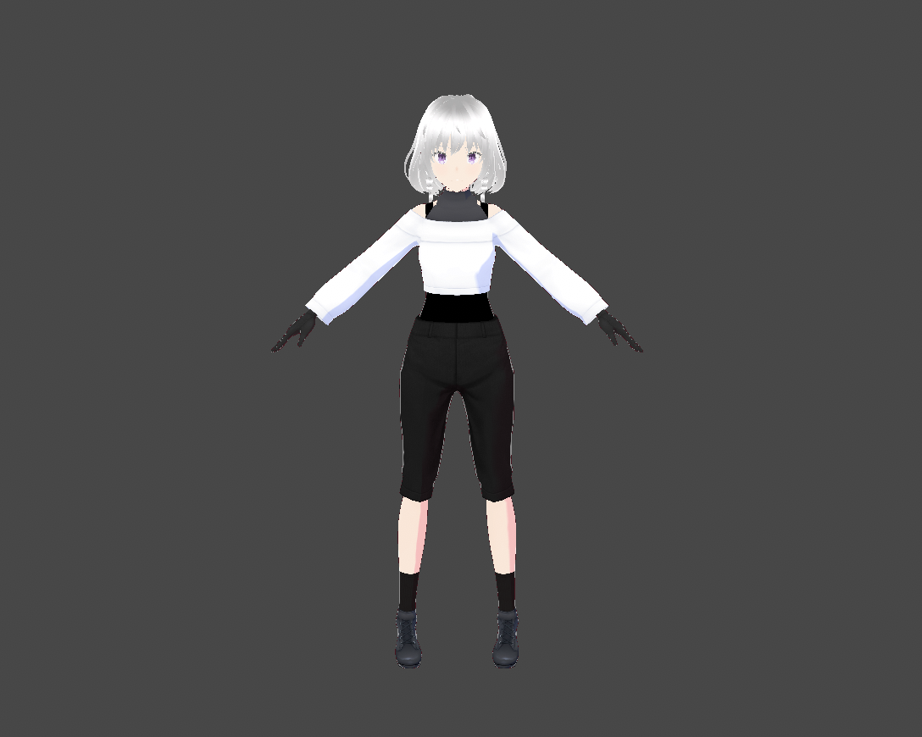

Model of the enemies (Download from unity assets store)

Enemy Plant 1

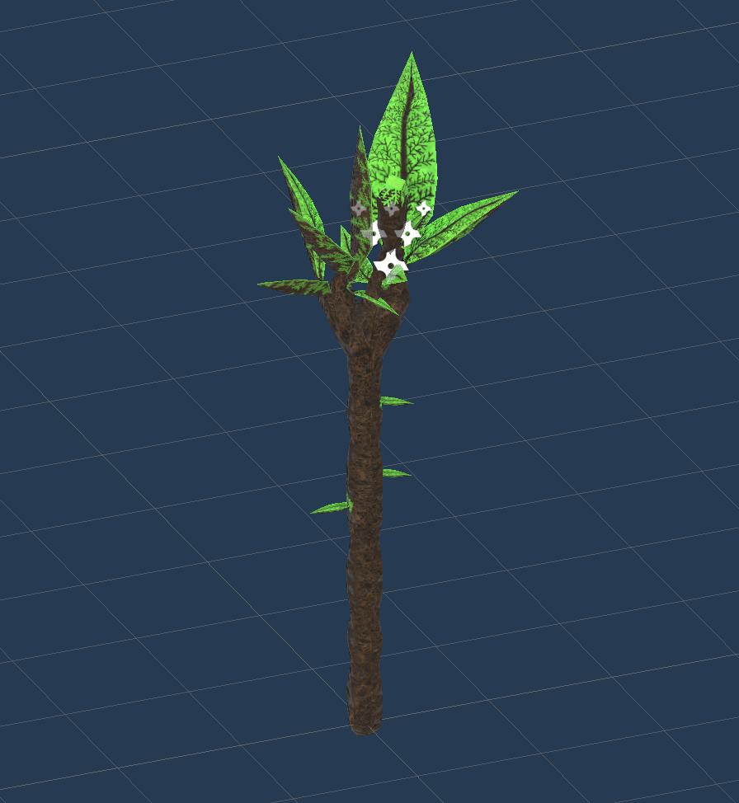

Enemy plant 2

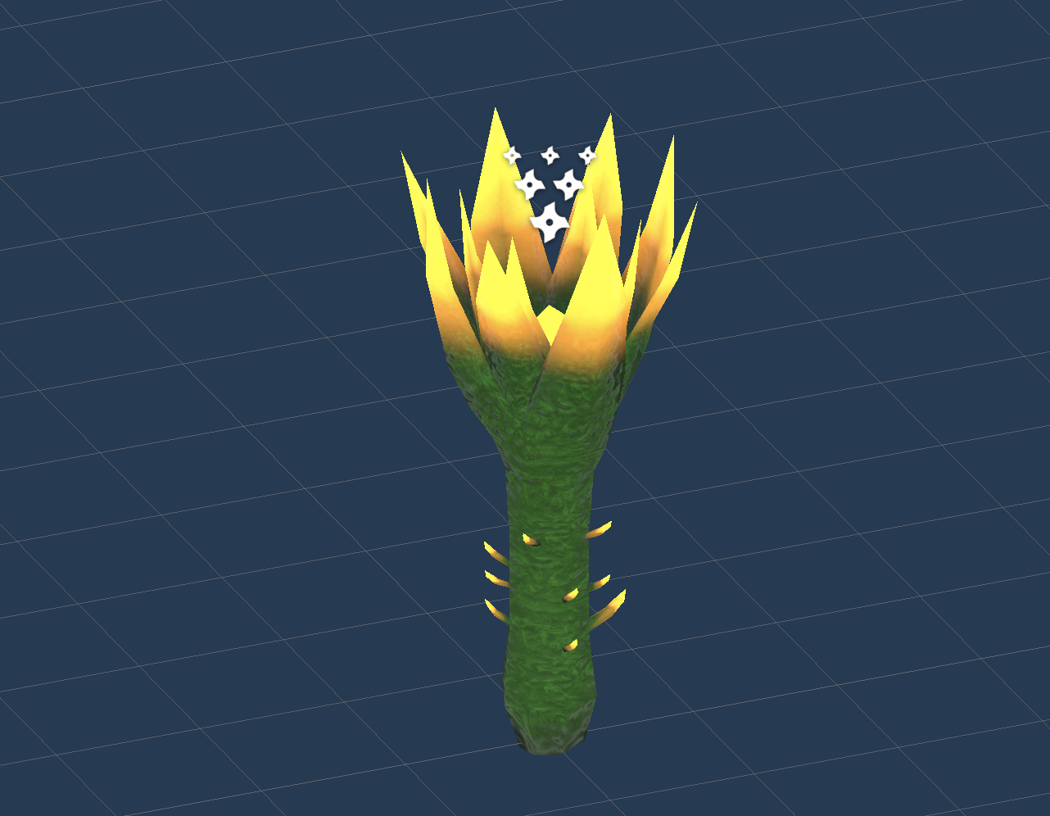

Enemy Plant 3  
 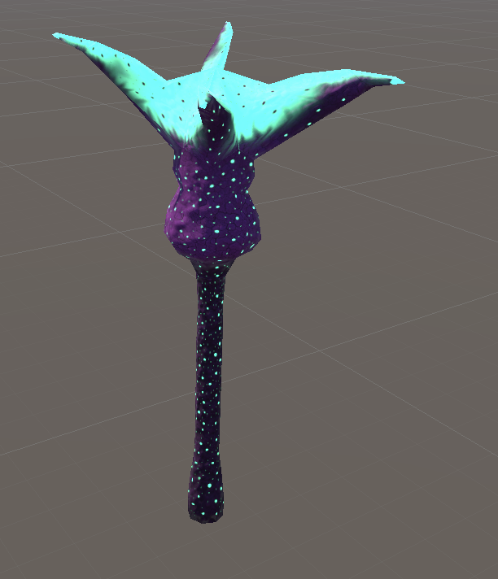

Enemy Skeleton

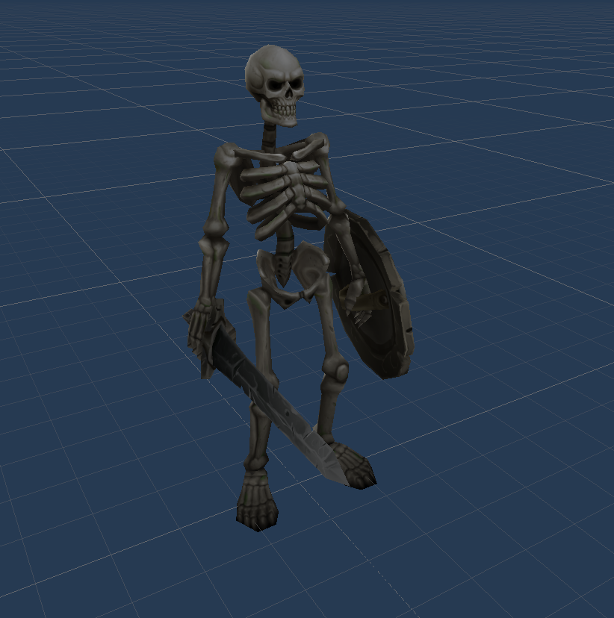

Model of the wolf

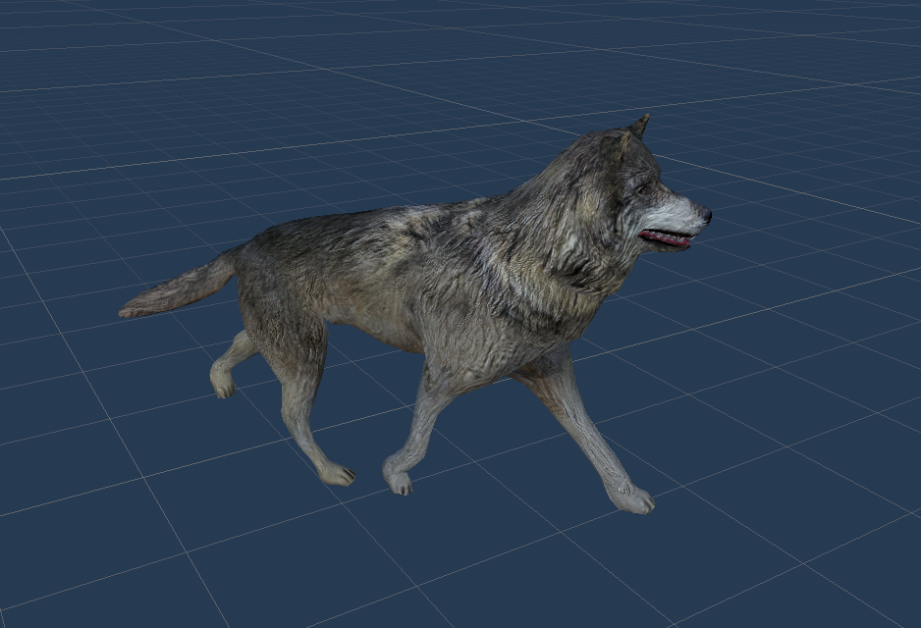

Model of the Rotkäppchen

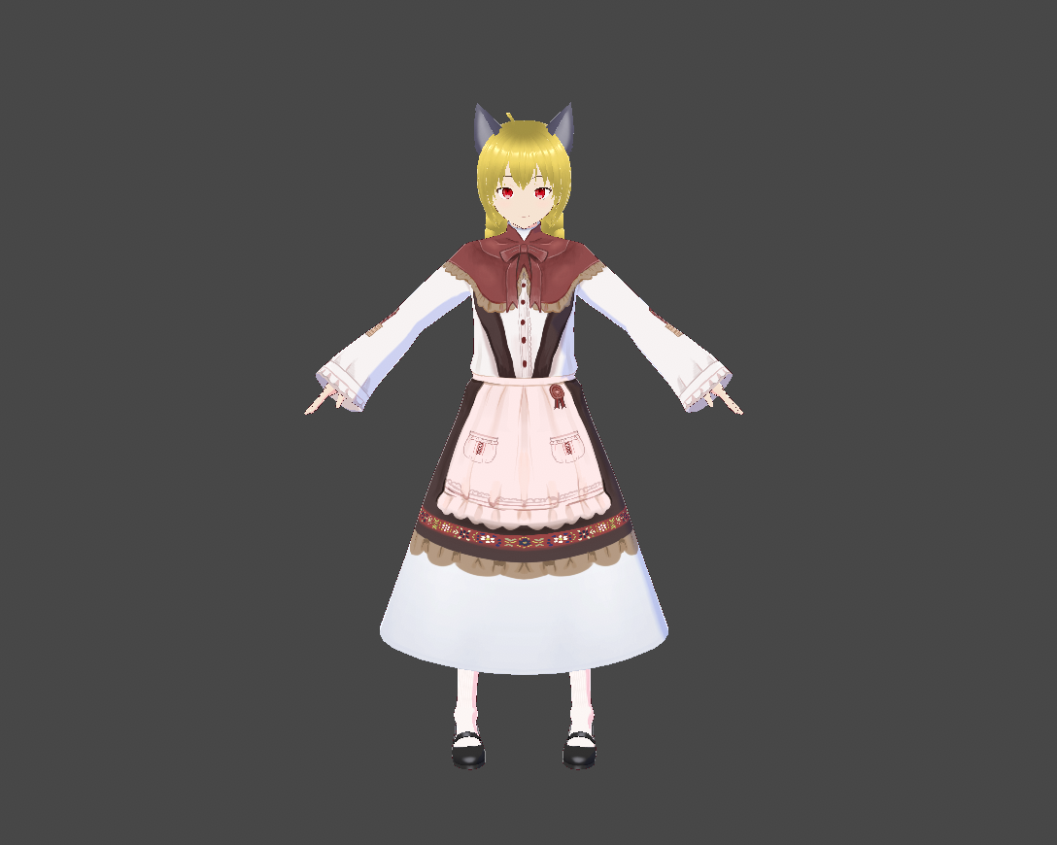

## Scenes after the menu page

Beginning

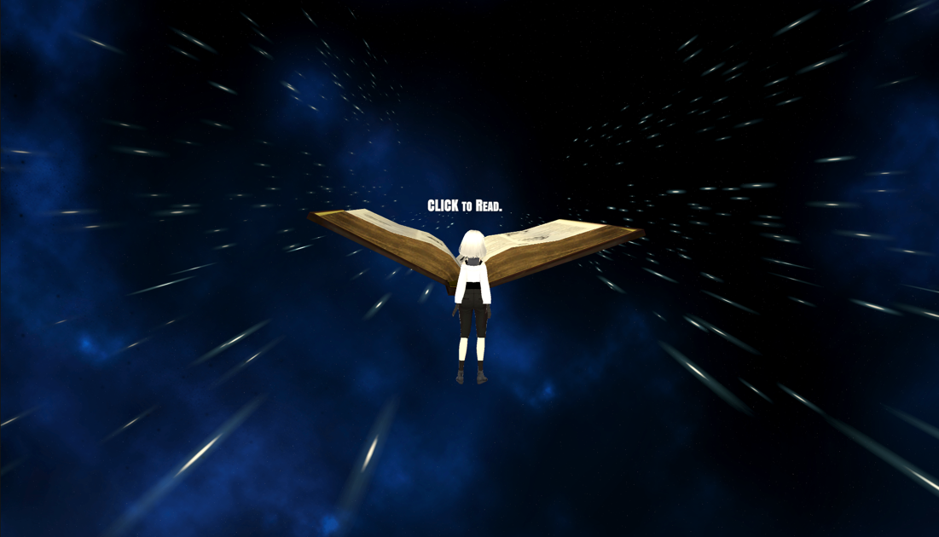

Town

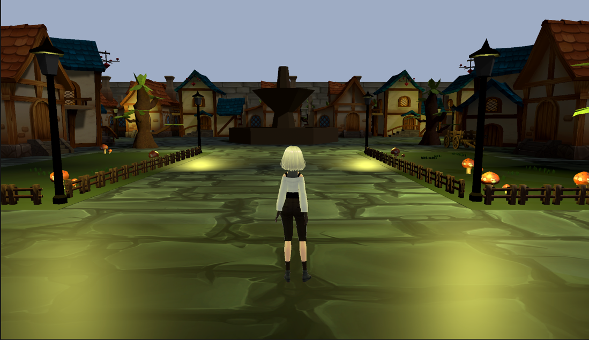

Rotkäppchen’s home in the town

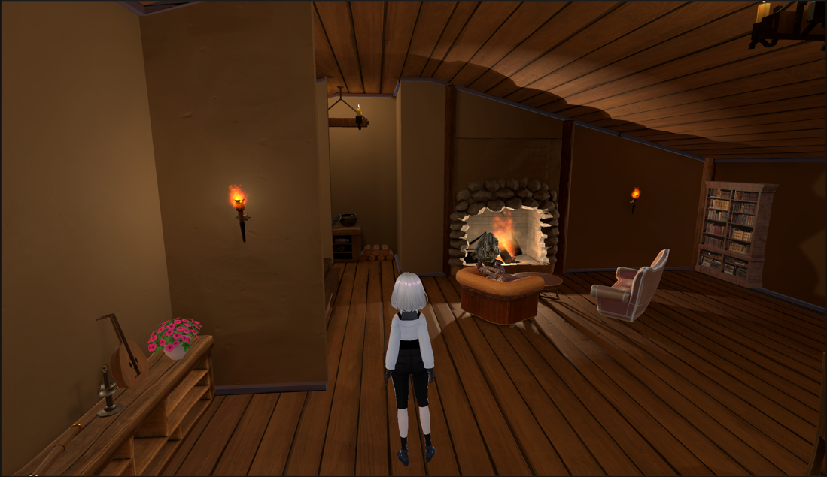

Forest

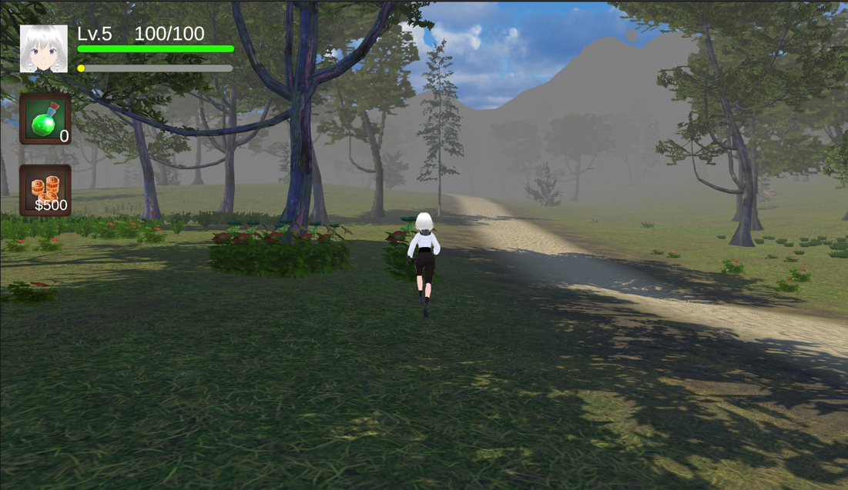

Cabin

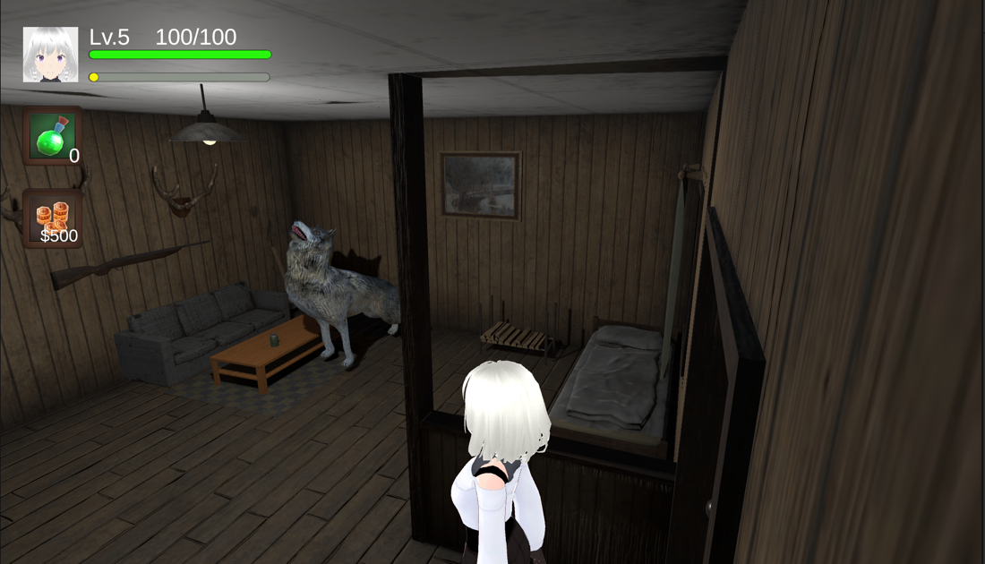

Final Scene

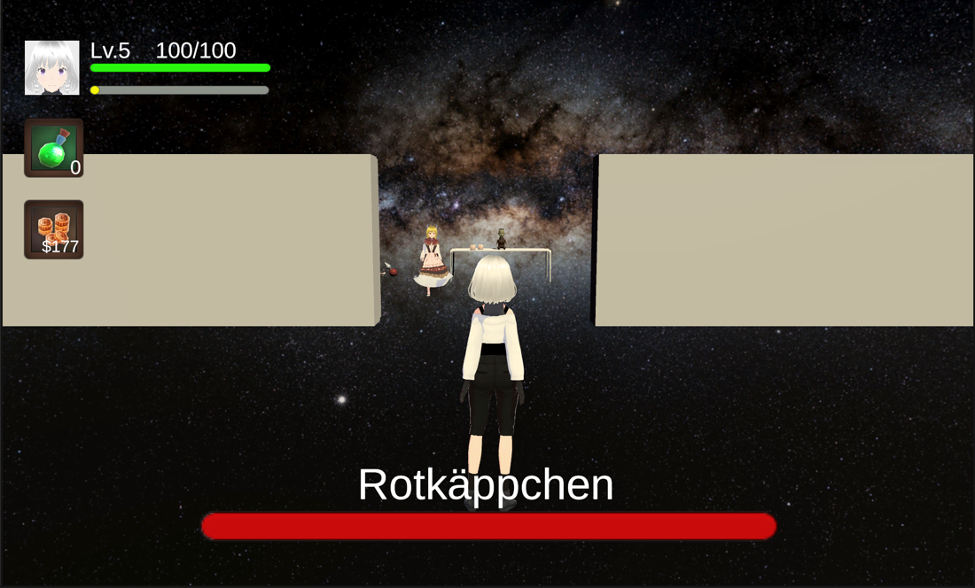

## UI

Bag Display

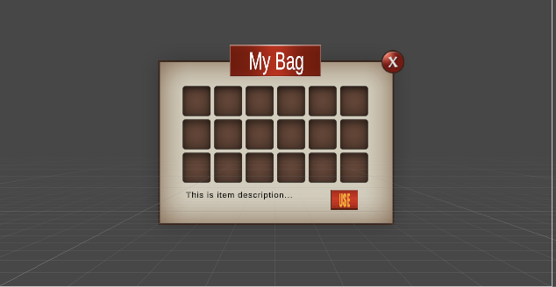

Dialog Display

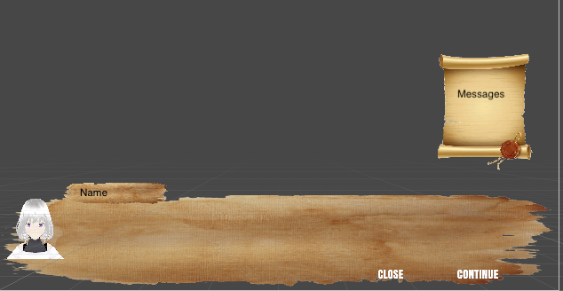

Attack Display

FireBall

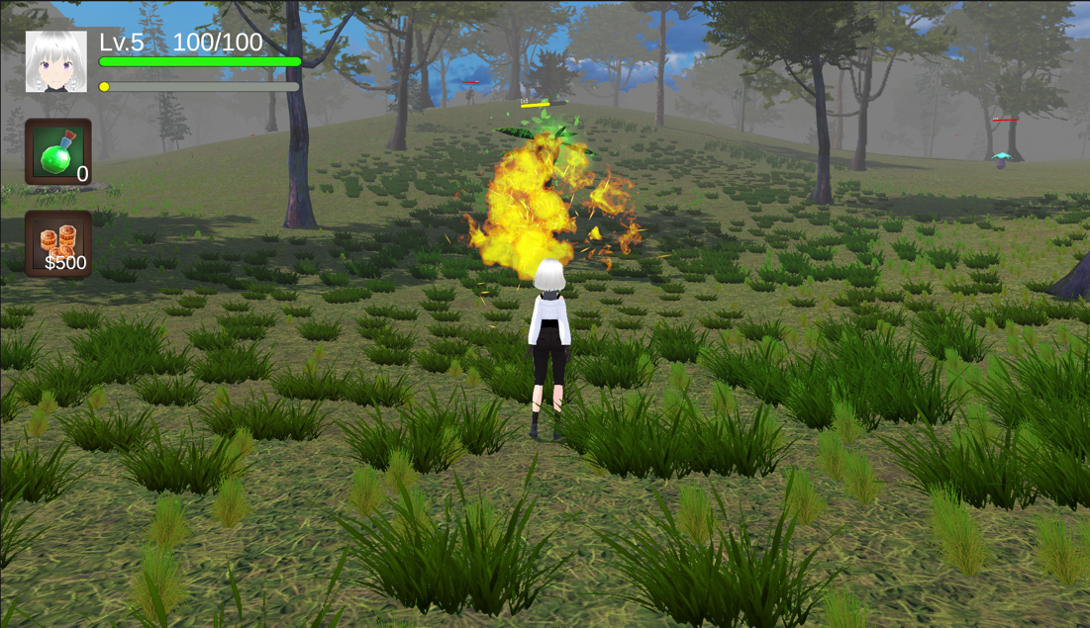

IceLance

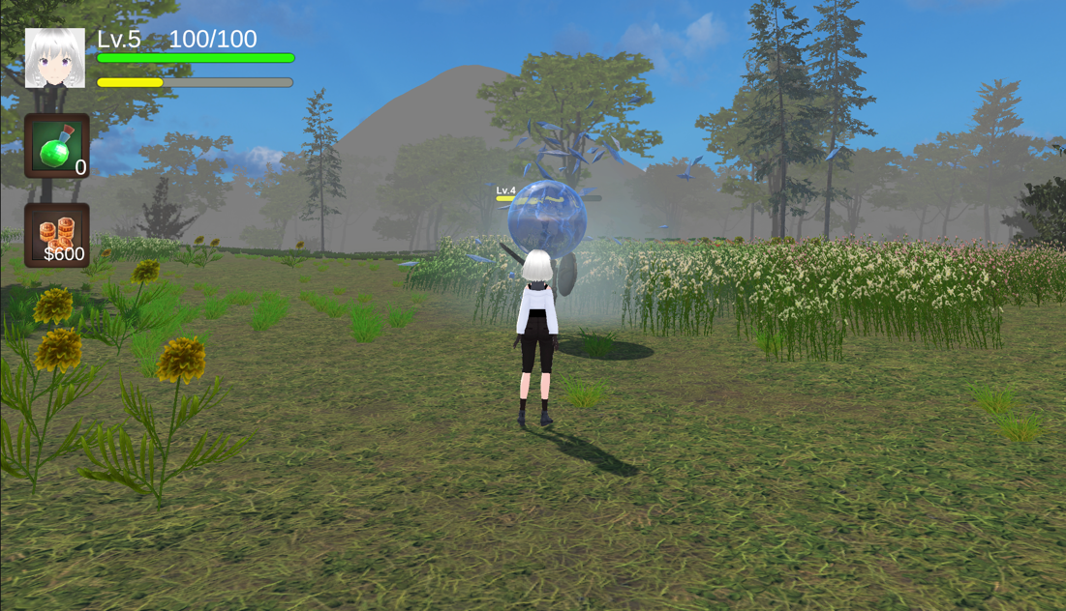

# Discussion and Conclusions

In our game, we have implemented the level of Little Red Riding Hood based on our initial design. From the project, we became more familiar with the unity game engine. We learned more about the lighting, UI, animation control in Unity and build our project.

Our current implementation has some drawbacks. If we get more time, we will improve the performance of our game. We will make the fighting system more interesting by increasing the character’s attacking method and types of monsters. We would also add more values to the player and the enemy such as ATK, magic ATK to add more variation to the battle. In the storytelling part, we should add more NPC dialogues and information to make the storytelling clearer. The current plot design is not mature for an RPG game. In addition, we will add the shopping function to allow the player to buy props with gold coins. We also want to add a save system to let the player save their playing status.

In conclusion, we tried to make an RPG game. We still have a lot of things to improve in this game.